**Experiment 6**

**Student Name:** Sahil Kaundal **UID:** 21BCS8197

**Branch:** CSE (Lateral Entry)  **Section/Group:** 616/A

**Semester:** 6th **Date of Performance:** 21/04/2023

**Subject Name:** Internet of Things Lab **Subject Code:** 20CSP-358

1. **Aim:**

Interfacing of Arduino/Raspberry Pi with temperature and humidity sensor with real time application.

1. **Objective:**

* Learn about Temperature sensor in detail.
* Learn about IoT programming.
* Measure the temperature with temperature and humidity sensor.

1. **Requirements:**

* Arduino Uno R3 board
* Ultrasonic sensor (HC-SR04)
* Jumper Wires

1. **Procedure:**

**DHT11 Sensor:**

DHT11 Module features a temperature & humidity sensor complex with a calibrated digital signal output. The exclusive digital-signal-acquisition technique and temperature & humidity sensing technology ensure high reliability and excellent long-term stability. This sensor includes an NTC for temperature measurement and a resistive-type humidity measurement component for humidity measurement. These are connected to a high- performance 8-bit microcontroller, offering excellent quality, fast response, anti-interference ability, and cost effectiveness.

**DHT11 Circuit Diagram:**

The schematic diagram for the DHT11 module is given below. As mentioned earlier, the board has a very low components count. The VCC and GND are directly connected to the DHT11 and a pullup resistor is added to the DATA pin. Sufficient filtering is provided with the tantalum and multilayer capacitors. An LED with a current limit resistor is used as a power indicator.

**Humidity Sensor:**

The humidity sensor is a device that senses, measures, and reports the relative humidity (RH) of air or determines the amount of water vapor present in gas mixture (air) or pure gas. Humidity sensing is related to a water adsorption and desorption process.

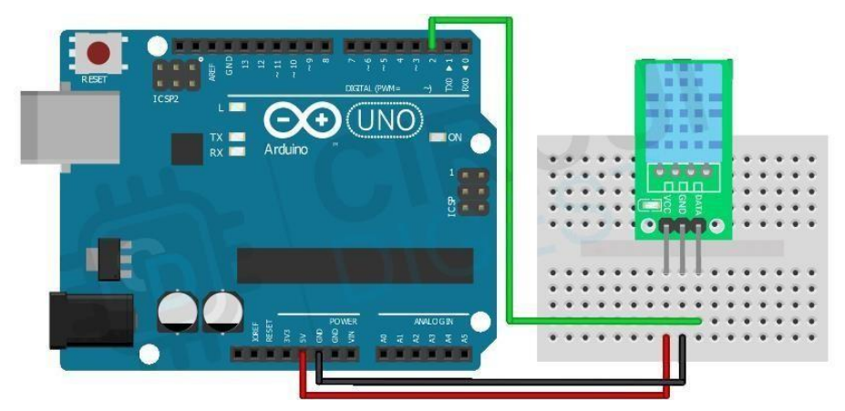

1. **Steps/Program:**

#include <dht.h>

dht DHT;

void setup() {

Serial.begin(9600);

}

void loop(){

int chk = DHT.read11(7); //digital pin 7 for input of temperature

Serial.print("temperature: ");

Serial.println(DHT.temperature);

Serial.print("humidity: ");

Serial.println(DHT.humidity);

delay(1000);

}

1. **Output:**

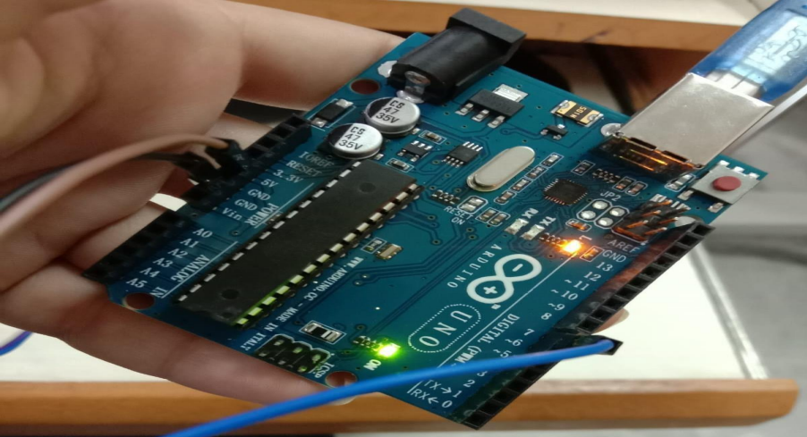

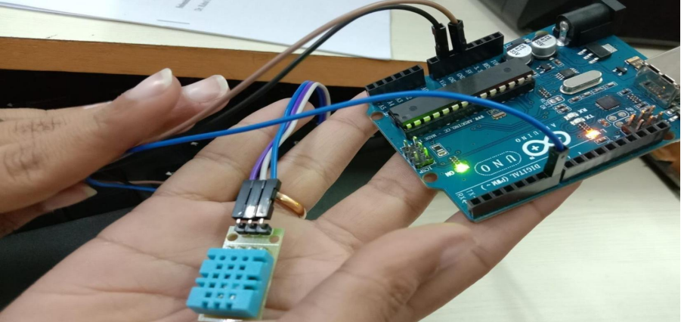

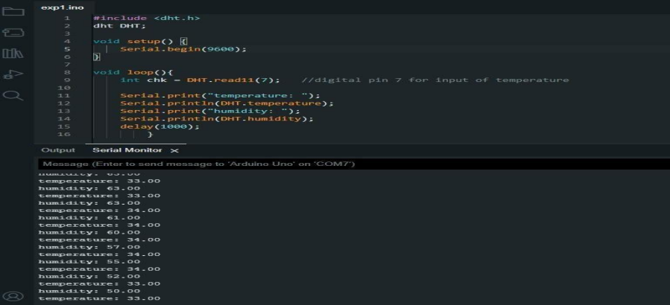

**Learning outcomes (What I have learnt):**

* Learned about Temperature sensor in detail.
* Learned about IoT programming.
* Measured the temperature with temperature and humidity sensor.

**Evaluation Grid (To be created as per the SOP and Assessment guidelines by the faculty):**

|  |  |  |  |
| --- | --- | --- | --- |
| Sr. No. | Parameters | Marks Obtained | Maximum Marks |
| 1. |  |  |  |